SWE20004 Technical Software Development Semester 2 2019

Assignment 1 report

Name: Jake Scott Student ID: 102581840

Lab class: Wednesday / 12:30 PM / BA601

Due Date: Friday 6th September 2019 at 11:59 pm

Date Submitted: Friday 6th September 2019 at *INSERT*

Assignment Title: 1

Program description
This program is used to encode and decode integers, with different rulesets based on how many digits there are in the integer. If a valid integer has been inputted by the user, then the program decides what rule set to apply to the input. Once the integer has been encoded then the program decodes the encoded number to ensure that the number is encoded correctly. Once both encoding and decoding is complete the data is then outputted to the screen.

Inputs and Outputs
The inputs and outputs for this program are described in Table 1.

Table 1. Data dictionary:
Data to be stored | Sample data | Type of data | C++ type | Input method | In /  Out | Variable name
first name | “Fritz” | text: 2-20 characters | string | cin | cout | firstName
Interest amount | $1333.22 | real number | double | cin | out | amount

3. Algorithm
Program steps:
  - Flush the keyboard
  - Prompt for input
  - Enter the number
  - Check range – if too small or too big return to a.

Coding logic:

Decoding logic:

You then can represent algorithm as pseudocode or flowchart.

Source code:

Copy the code from visual studio or text editor you are using and paste it here

Screenshots showing working program (Show all possible outcome):

Paste in views of your program running in a msys, Mac or Linux command window
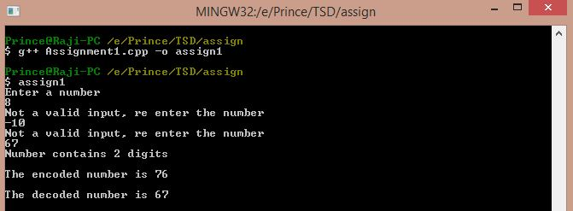

Task 2.11

Program description

Source Code

Screenshots showing working program

Task 3.8

Program description

Source Code

Screenshots showing working program

Task 4.9

Program description

Source Code

Screenshots showing working program

